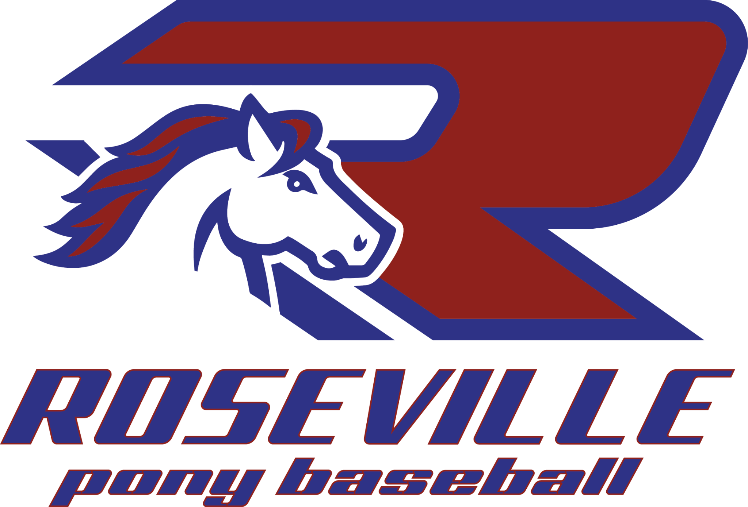
Local PONY Ground Rules - All Leagues
Pinto 7
- Base lengths are to be 60’.
- No bunting.
- 10 defensive players throughout the season.
- Upon the batter hitting the ball in play, the baserunner shall not slide into first (1st) base. Should this occur, the player will be called out.
- Players shall not advance on an overthrow.
- Weeks 1-5 shall be coach only pitch.
- Weeks 6 through the balance of the season shall be player pitch only pitch.
- Base runners shall be eligible to steal bases during player pitch only. They may not leave their base until after the ball crosses the plate. If a player leaves early they are sent back to the original base, unless it is a batted ball, then they are called out.
- Should an at-bat reach a 4th ball called, the coach of the team batting will come in and assume the count.
- Scores and player pitch counts to be submitted after each game, all games to use GameChanger.
- If a pitcher hits three (3) batters in one inning they must be pulled from the mound.
- Games are scheduled for 6 innings. Each of the first five (5) innings will last three (3) outs or five (5) runs, whichever comes first. The 6th inning will last three (3) outs or ten (10) runs, whichever comes first.
- A player may only play the pitcher or catcher position combined for a total of four (4) innings.
- No player shall sit two (2) innings until every player sits one (1).
- Every player must play a full defensive inning within the infield by the 3rd inning.
- Manager shall be suspended the following game should a player exceed the players age daily maximum pitch count.
- No new inning shall begin after one (1) hour and (15) fifteen minutes
- Drop dead (end of game) shall be enforced after one (1) hour and (30) thirty minutes has occurred.

Local PONY Ground Rules - All Leagues
Pinto 8
- Base lengths are to be 60’.
- No bunting.
- The team on defense shall only position nine (9) players.
- Upon the batter hitting the ball in play, the baserunner shall not slide into first (1st) base. Should this occur, the player will be called out.
- Players shall not advance on an overthrow.
- Player pitch throughout the entire season.
- Weeks 1-5, should an at-bat reach a 4th ball called, the coach of the team batting will come in and assume the count.
- If a pitcher hits three (3) batters in one inning they must be pulled from the mound.
- Weeks 6 through the balance of the season, should an at-bat reach a 4th ball called, the batter shall be awarded 1st base.
- Scores and player pitch counts to be submitted after each game, all games to use GameChanger.
- Base runners shall be eligible to steal bases throughout the entire season during player pitch only. They may not leave their base until after the ball crosses the plate. If a player leaves early they are sent back to the original base, unless it is a batted ball, then they are called out.
- Games are scheduled for 6 innings. Each of the first five (5) innings will last three (3) outs or five (5) runs, whichever comes first. The 6th inning will last three (3) outs or ten (10) runs, whichever comes first.
- A player may only play the pitcher or catcher position combined for a total of four (4) innings.
- No player shall sit two (2) innings until every player sits one (1).
- Every player must play a full defensive inning within the infield by the 3rd inning.
- Manager shall be suspended the following game should a player exceed the players age daily maximum pitch count.
- No new inning shall begin after one (1) hour and (15) fifteen minutes
- Drop dead (end of game) shall be enforced after one (1) hour and (30) thirty minutes has occurred.

Local PONY Ground Rules - All Leagues
Mustang
- Base lengths are to be 60’.
- Pitching distance to be 46’.
- Players who pitch the daily maximum # of pitches will not be eligible to catch.
- Five (5) run maximum per inning for innings one (1) through four (4).
- Ten (10) run maximum allowed in the fifth (5th) inning.
- Unlimited runs allowed in the sixth (6th) inning.
- No player shall sit two (2) innings until every player sits one (1).
- Every player must play a full defensive inning within the infield by the 3rd inning.
- A player may only play the pitcher or catcher position combined for a total of five (5) innings.
- Upon the batter hitting the ball in play, the baserunner shall not slide into first (1st) base. Should this occur, the player will be called out.
- Each pitcher shall receive one (1) warning from the umpire when they balk. Following that, balks shall be enforced.
- If a pitcher hits three (3) batters in one inning they must be pulled from the mound.
- Runners shall not advance home on a delayed or straight steal, home can only be taken on a batted, passed, or overthrown ball.
- No new inning shall begin after two (2) hours.
- Drop dead (end of game) shall be enforced after two (2) hours and fifteen minutes (2:15) has occurred.
- Teams may obtain enough players to achieve nine (9) total players from the opposing team. A forfeit does not occur until a team falls under seven (7) players.
- Drop 3rd Strike rule is in effect all season.
- The infield fly rule shall not be enforced.

Local PONY Ground Rules - All Leagues
Bronco
- Base lengths are to be 70’.
- Pitching distance to be 50’.
- Players who pitch the daily maximum # of pitches will not be eligible to catch.
- Ten (10) run maximum per inning for innings one (1) through six (6).
- Unlimited runs allowed in the seventh (7th) inning.
- No player shall sit two (2) innings till every player sits one (1).
- All players must play a minimum of three (3) innings within the game.
- Upon the batter hitting the ball in play, the baserunner shall not slide into first (1st) base. Should this occur, the player will be called out.
- Each pitcher shall receive one (1) warning from the umpire when they balk. Following that, balks shall be enforced.
- Guest players are permitted and must be enrolled within the Mustang Division.
- Guest players must bat last and are ineligible to pitch or catch.
- Teams may obtain enough players to achieve nine (9) total players from the opposing team. A forfeit does not occur until a team falls under seven (7) players.
- The infield fly rule is in full force throughout the season.
- Drop third strike rule is in effect throughout the season.
- A player may only play the pitcher or catcher position combined for a total of six (6) innings.
- No new inning shall begin after two (2) hours and fifteen (15) minutes.
- Drop dead (end of game) shall be enforced after two (2) hours and thirty minutes (2:30) has occurred for sunset, drop dead does not apply at Rocklin Fields.

Local PONY Ground Rules - All Leagues
Pony
- Base lengths are to be 80’.
- Pitching distance to be 54’.
- No warnings for balks.
- Players who pitch the daily maximum # of pitches will not be eligible to catch.
- Unlimited runs allowed in all seven (7) innings.
- Upon the batter hitting the ball in play, the baserunner shall not slide into first (1st) base. Should this occur, the player will be called out.
- No new inning after two (2) Hours and thirty (30) minutes
- No drop-dead time.
- Guest players are permitted and must be enrolled within the Bronco Division.
- Guest players must bat last and are ineligible to pitch or catch.
- Teams may obtain enough players to achieve nine (9) total players from the opposing team. A forfeit does not occur until a team falls under seven (7) players.
- No player shall sit two (2) innings till every player sits one (1).
- All players must play a minimum of three (3) innings within the game.

Local PONY Ground Rules - All Leagues

Disciplinary
- Should a player use an illegal bat in any division, the manager will be suspended for the following game.
- Manager shall be suspended the following game should a player exceed the players age daily maximum pitch count.
- Managers are responsible for their players' parents' behavior, we have zero tolerance for unsportsmanlike behavior towards umpires, players, or other spectators.

PONY Rulebook Reference Rules
- Legal Bats
  - USA Baseball
  - BBCOR -3
  - Wood
- TeeBall Bats can not be used above the Shetland division.
- USSSA Bats are illegal at all times, no exceptions.
- If a coach visits the mound twice in one inning, the pitcher must be pulled.
- A pitcher can not reenter a game in the pitchers position after they are pulled from the mound and the inning ends
- The pitchers pitch count reverts back to the first pitch of the last batter faced for rest day counting.
- Mercy rule applies in Pinto-Pony divisions, please reference the PONY Rulebook for details.
- There is no out for a player missing an at bat due to an injury, illness, or pre-declared absence. An out will still apply if a team bats out of order unless it is for the previously mentioned reasons.
- Courtesy runners are not allowed unless an injury occurs, or a player is injured prior to the game and the other manager is notified at the plate meeting, in which case the last batted out shall become the courtesy runner.

